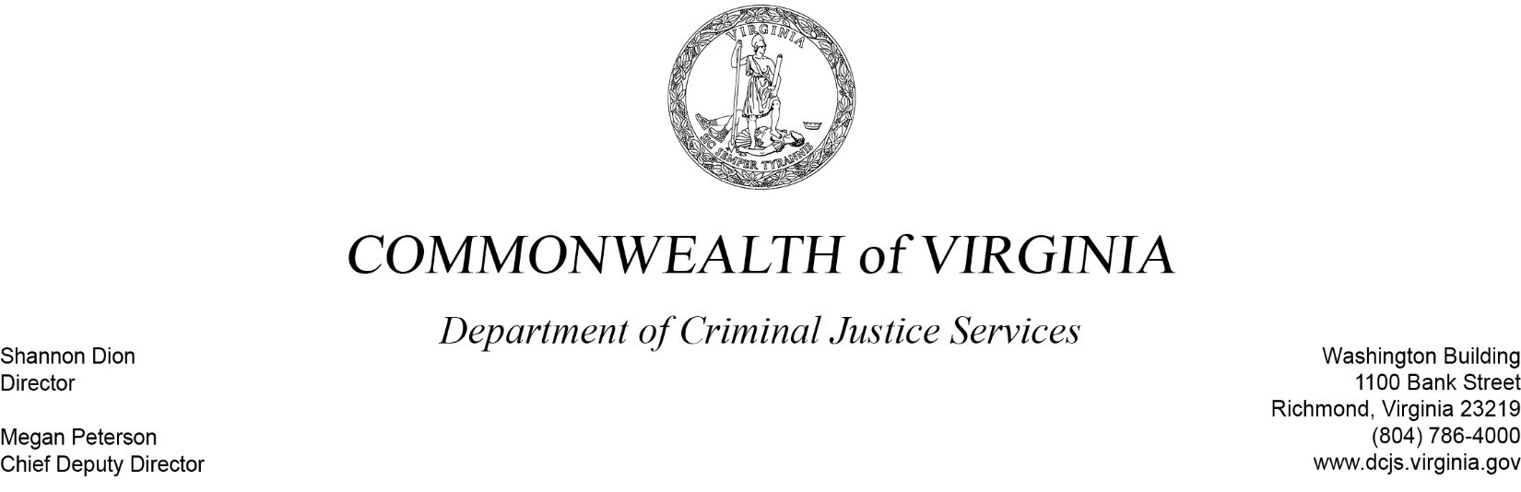
February 5, 2020

Ms. Kathleen L. Wright
Board President, VPLC
10 Franklin Road, SE Ste. 900
Roanoke, VA 24022-0013

RE: Improving Criminal Justice Responses Grant Program (ICJR)

Dear Ms. Wright:

Congratulations on being a recipient of the above referenced grant program! Your DCJS grant award number is 20-A4965JR19 and was approved for a total award of $131,348 funded through Federal Grant 2019-WE-AX-0007. The project period for this program is 10/01/2019 through 09/30/2022.

Enclosed you will find the Statement of Grant Award (SOGA) and Special Conditions documents, along with Reporting Requirements and Projected Due Dates. To indicate your acceptance of the award and conditions, please sign the SOGA and return it electronically within the next 60 days to grantsmgmt@dcjs.virginia.gov. Review the conditions carefully as some may require action on your part before we will disburse grant funds.

Please provide copies of this Award Package to those contacts listed on your grant application. We will be happy to assist you in any way we can to assure your project’s success. If you have any questions regarding this award, please contact your Grant Monitor, Andi Martin at 804.371.0534 or via email at andi.martin@dcjs.virginia.gov.

Sincerely,

Shannon Dion
Enclosures

STATEMENT OF GRANT AWARD (SOGA)

Virginia Department of Criminal Justice Services
1100 Bank Street, 12th Floor
Richmond, Virginia
Federal Funds: $ 131,348 Indirect Cost Rate: _____%
State General Funds: $ 0 *If applicable
State Special Funds: $ 0
Local Match: $ 0

Total Budget: $ 131,348

Federal Grant Number: 2019-WE-AX-0007
Federal Awardee: OVW
Federal Catalog Number: 16.590
Project Description: Assist Virginia localities with the development of Sexual Assault Response Teams (SART), lethality assessment programs (LAP), Fatality Review Teams, and legal advocacy programs.

Subgrantee: Va Poverty Law Center, Inc.
DUNS Number: 037427077 DCJS Grant Number: 20-A4965JR19
Grant Start Date: 10/01/2019 Grant End Date: 09/30/2022

Improving Criminal Justice Responses Grant Program (ICJR)

Project Director | Project Administrator | Finance Officer
Ms. Susheela Varky  Dir., Cntr for Family Advocacy  Virginia Poverty Law Center, Inc.  919 E. Main Street, Ste. 610  Richmond, VA 23219-4600  (804) 351-5274  susheela@vplc.org | Ms. Kathleen L. Wright  Board President, VPLC  10 Franklin Road, SE Ste. 900  Roanoke, VA 24022-0013  PO Box 40013, Roanoke, VA 24022-0013  (540) 983-9360  Wright@gentrylocke.com | Ms. Ann Voss  Office Mgr/Finance Officer  Virginia Poverty Law Center  919 E. Main Street, Ste. 610  Richmond, VA 23219-4600  (804) 351-5257  ann@vplc.org
As the duly authorized representative, the undersigned, having received the Statement of Grant Awards (SOGA) and Special Conditions attached thereto, hereby accepts this grant and agree to the conditions and provisions of all other Federal and State laws and rules and regulations that apply to this award.

Signature: ______________________________
Authorized Official (Project Administrator)

Title: ______________________________

Date: ______________________________

